# 

# 

# 

# **Elderly Fall Detection using Transfer Learning**

# **Mohamed Serageldin**

# 

# 

# 

# **TABLE OF CONTENTS**

# **Page**

**Problem statement 3 Related Work 4 - 9**

**Model Architecture 10**

**Results & Strategies 11**

# 

# 

**Problem Statement**

Falls are a major problem for the elderly people living independently. According to the World Health Organization, falls and sustained injuries are the third cause of chronic disability. Many elderly people are living alone in their homes. If the elderly fall down, it may be difficult for them to request help. After a fall occurs, medical attention needs to be provided promptly in order to reduce the risk of the victim. Several technologies have been developed which utilize webcams to monitor the activities of elderly people.

**Related Work**

We made our research and found various papers and methods used by different doctors and professors to implement the falls detection system :-

**•Human-fall Detection from an Indoor Video Surveillance.**

**•Elderly fall detection based on multi-stream deep convolutional networks.**

**•Fall Detection in Elderly Care System Based on Group of Pictures.**

1. **Human-fall Detection from an Indoor Video Surveillance**

In this paper, it presents a human fall detection method from visual surveillance. In the first step, background subtraction is performed using Improved GMM to find the foreground objects. In the second step, contour based human template matching is applied to categorize the human or non- human object. It helps to detect fall incidents by providing sudden change in generated score after matching. Height-width ratio is computed in the third step to decide whether the human shape is changed or not. In the fourth step, the distance between top and mid center of a rectangle covering a human is computed, if it is less than a certain threshold, then human fall is confirmed. Finally, if the inactive pose of humans is continued till 100 consecutive frames, then an alarm is generated to alert the people at home to provide treatment on time. Experiments have been performed on 21 video sequences having different usual and unusual fall incidents. Experimental results show that the proposed system works well efficiently and effectively in real-time for recognizing human fall.

**Steps of the process:**

**Step1:** Contour object from the foreground frame of the video sequence is cropped.

**Step2:** Applied Sobel operator to compute the gradients of X and Y direction Gx and Gy.

**Step3:** We compute magnitude and direction after finding gradient as per the formula specified below

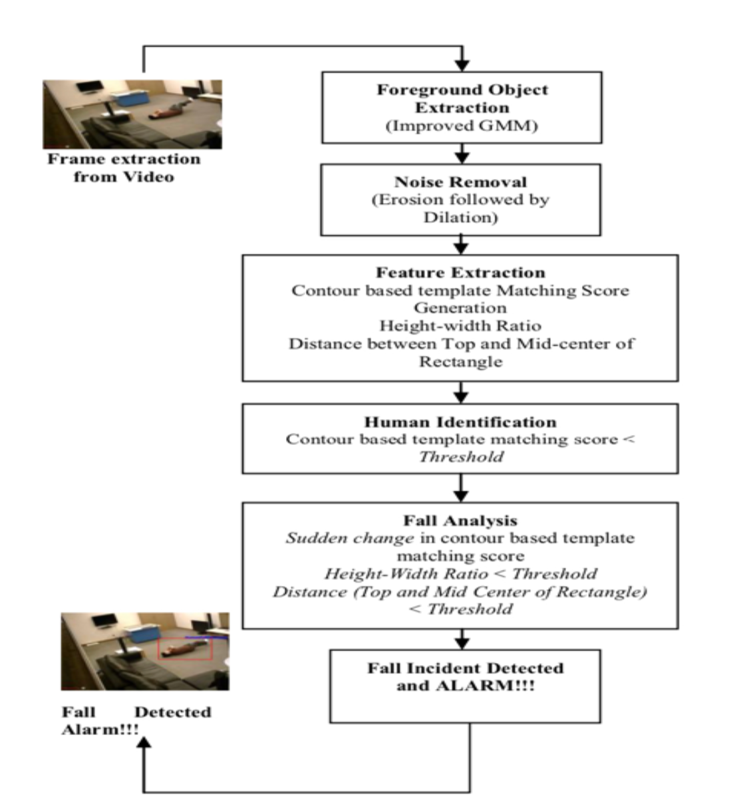

**Step4:** After computation of edge direction, we have four possible directions i.e.0, 45, 90, 135 degrees, to describe the surrounding pixels.

**Step5:** We performed non-maximum suppression to make a thin edge, in which right and left pixels are traced in the edge direction and suppresses the current pixel magnitude if it is less than the right and left magnitude of the pixel.

**Results :**

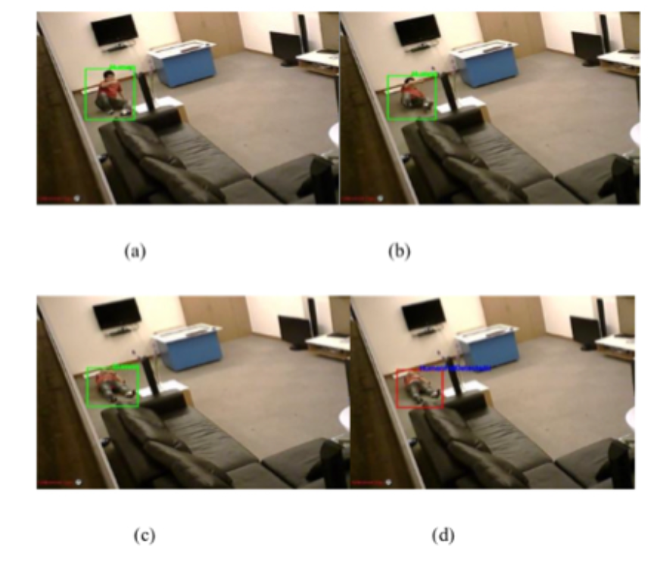

**Step6:** We save Gx and Gy which are X anTable below shows the accuracy of human fall detection which is 95.20% with 3.33% false detection. Table 1 (in first row) shows that the proposed system detected human fall incidents in 20 out of 21 videos and the proposed system failed in fall detection in one video sequence. Table 1 (second row) shows that the proposed system failed in one video of the dataset and falsely detected one daily routine as a fall incident and in 29 videos, usual activities have been detected as usual activities.

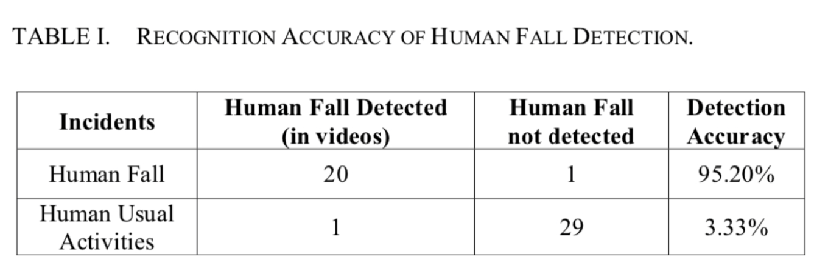

1. **Elderly fall detection based on multi-stream deep convolutional networks.**

In this paper, they propose weighted multi-stream deep convolutional neural networks that exploit the rich multimodal data provided by RGB-D cameras. Their method detects fall events automatically and sends a help request to the caregivers. their contribution is threefold. They build a new architecture composed of four separate CNN streams, one for each modality. The first modality is based on a single combined RGB and depth image to encode static appearance information. RGB image is used to capture color and texture and depth image deals with illumination variations. In contrast to the first feature that lacks the contextual information about previous and next frames, the second modality characterizes the human shape variations.

**Steps of process:**

In this section, they describe the different information used as input for the proposed multi- steam CNN architecture. In particular, we use RGB images, depth images, optical flow displacement, history of binary motion images, amplitude and orientation flow. This set of features will cover motion, shape and appearance information of elderly person activities.

**Results:**

They have proposed a multi-stream convolutional neural network for elderly fall detection using RGB-D cameras. Their method is based on deep learning architecture that analyzes both the appearance, motion and the shape variations. Human motion detection before fall recognition excludes background thus allowing our method to better perform on various situations, in indoor or outdoor

environments. Multi-stream deep architecture is fused to extract complementary features from RGB images, depth images, optical flow displacement, history of binary motion images, amplitude and orientation optical flow. Transfer learning and data augmentation are used to overcome the problem posed by the low number of images in fall datasets and to learn generic features.

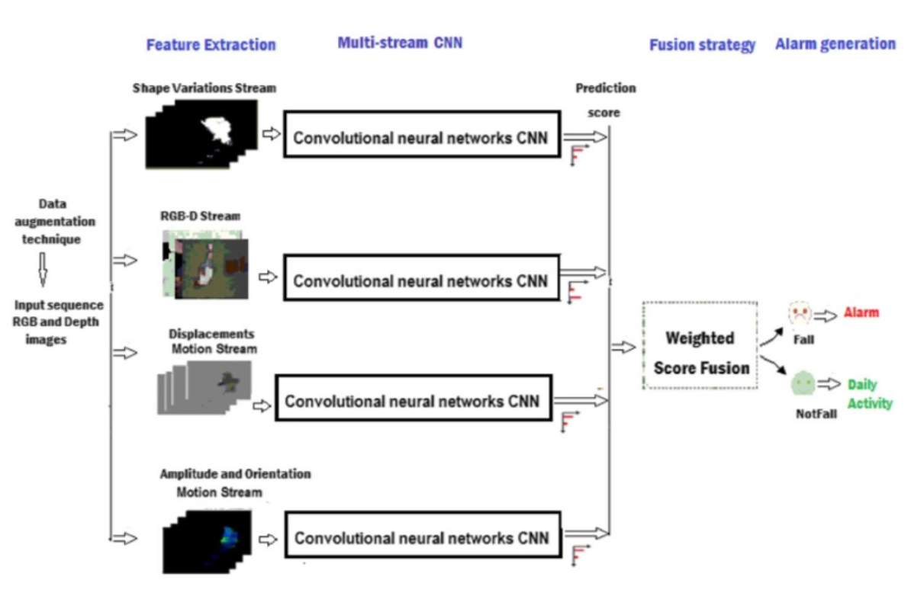

1. **Fall Detection in Elderly Care System Based on Group of Pictures.**

A new method is proposed to detect falls, which are one of the greatest risks for seniors living alone. The overall system architecture of the proposed method is shown in below figure

This section elaborates the architecture, algorithm and all the methods involved in the proposed method. This paper introduces a keyframe based approach in identifying fall. For achieving the objective, this work uses four phases: Foreground Seg-mentation, Keyframe Extraction, Fall Identification and Motion Quantification. Initially, the video is partitioned into GOP based on changes in scene. A scene change identif̄cation algorithm is introduced based on correlation factor.27 Then, Optical flow is calculated between keyframes of each GOP. If the optical identifies large motion, then there is a fall.

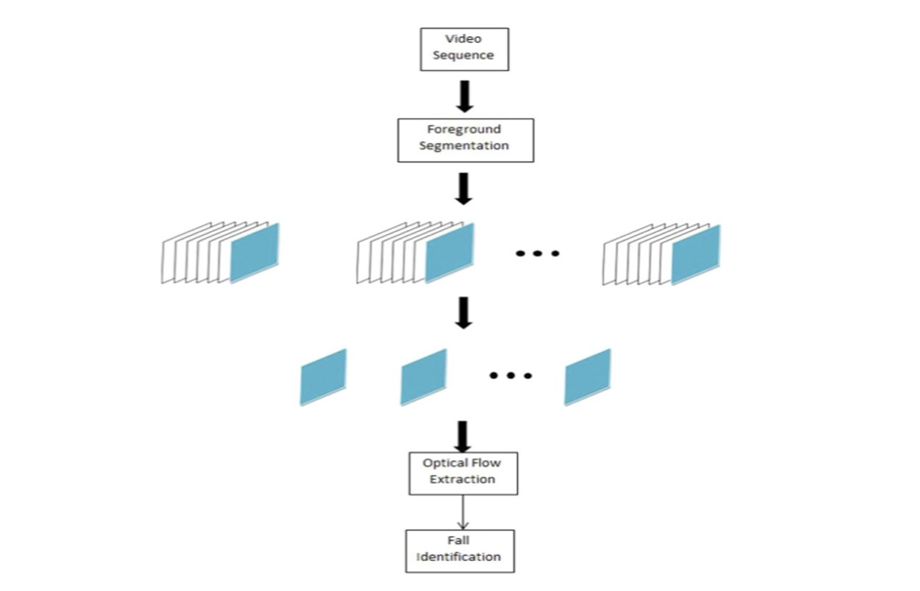

**Model Architecture**

Our main model takes a live-stream / Video as an input then slices it up into frames and for each frame we are applying an image processing layer to achieve a foreground subtraction using Mixture of Gaussian (MOG).

For each frame the main model sends a copy to the VGG16 model (Transfer Learning pre-trained model) to predict whether the person is falling or not.

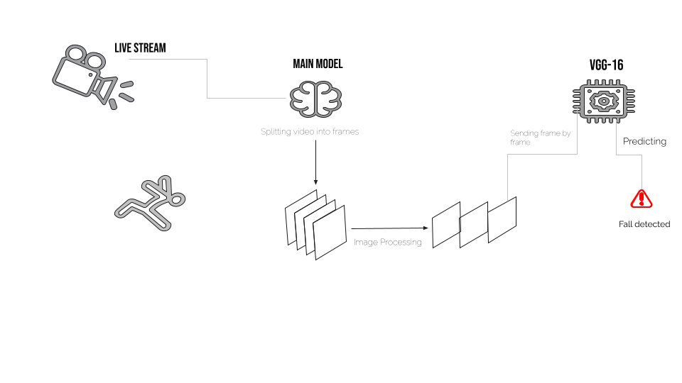

**Results & Strategies**

In order to compare the accuracy of mentioned classiﬁcation algorithms, the same method was applied to all of them, The 80% data was used for training and the remaining was used for testing purposes.

We were able to achieve an accuracy of 95% as a prediction of our VGG16 model.Our main model displays the processed video(MOG) along with the original video while sending each frame to the pre-trained model then prints the model response whether Fall or Not.

